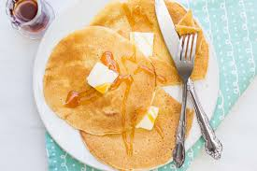
Georgina’s Sour Cream Pancakes
Prep Time 5 min Cook Time 10 min
4 Servings
Ingredients
3 eggs beaten
1 cup water
1 cup sour cream
1 cup flour
¼ cup sugar
2 tsp baking powder
Directions
- In a small bowl, beat the eggs. Add in water and sour cream.
- Stir in flour, sugar, and baking powder. Whisk well to combine. Batter may have a few small lumps.
- Heat a large skillet (nonstick or cast iron) or griddle over medium. If necessary, spray skillet with oil or cooking spray.
- Pour approximately 1/8 cup of batter for each pancake.
- Cook until the surface of the pancakes have some bubbles and a few have burst, 1 to 2 minutes.
- Flip carefully with a thin spatula and cook an additional 1 to 2 minutes. Serve warm with desired toppings.

